
Sem 1 Examination 2015

Question/answer booklet

MATHEMATICS
APPLICATIONS
UNIT 1

Section Two:
Calculator-assumed
Name:

Teacher:

Time allowed for this section
Reading time before commencing work: 10 minutes
Working time for paper: 100 minutes

Material required/recommended for this paper

To be provided by the supervisor
This question/answer Booklet
Formula sheet (retained from Section One)

To be provided by the candidate
Standard items: pens, pencils, pencil sharpener, eraser, correction fluid/tape, ruler, highlighter

Special items: drawing instruments, templates, notes on two unfolded sheets of A4 paper, and up to three calculators satisfying the conditions set by the Curriculum Council for this course.

Important note to candidates
No other items may be taken into the examination room. It is your responsibility to ensure that you do not have any unauthorised notes or other items of a non-personal nature in the examination room. If you have any unauthorised material with you, hand it to the supervisor before reading any further.

Structure of this paper

Section | Number of questions available | Number of questions to be answered | Working time  (minutes) | Marks  available | Percentage  of exam
Section One:  Calculator-free | 6 | 6 | 50 | 50 | 35
Section Two:  Calculator-assumed | 13 | 13 | 100 | 100 | 65
 |  |  | Total | 150 | 100

Instructions to candidates

- The rules for the conduct of Western Australian examinations are detailed in the Year 12 Information Handbook. Sitting this examination implies that you agree to abide by these rules.

2. Write your answers in the spaces provided in this Question/Answer Booklet. Spare pages are included at the end of this booklet. They can be used for planning your responses and/or as additional space if required to continue an answer.
  - Planning: If you use the spare pages for planning, indicate this clearly at the top of the page.
  - Continuing an answer: If you need to use the space to continue an answer, indicate in the original answer space where the answer is continued, i.e. give the page number. Fill in the number of the question(s) that you are continuing to answer at the top of the page.

3. Show all your working clearly. Your working should be in sufficient detail to allow your answers to be checked readily and for marks to be awarded for reasoning. Incorrect answers given without supporting reasoning cannot be allocated any marks. For any question or part question worth more than two marks, valid working or justification is required to receive full marks. If you repeat an answer to any question, ensure that you cancel the answer you do not wish to have marked.

4. It is recommended that you do not use pencil except in diagrams.

MARK ALLOCATION AND RECORDS:

Section | Question | Marks | Awarded
TWO | 7 | 5
TWO | 8 | 3
TWO | 9 | 5
TWO | 10 | 7
TWO | 11 | 7
TWO | 12 | 6
TWO | 13 | 12
TWO | 14 | 7
TWO | 15 | 13
TWO | 16 | 17
TWO | 17 | 4
TWO | 18 | 8
TWO | 19 | 6
 | TWO | 100
 | TOTAL | 150 |  |  | %

7. (5 marks)
A fishing rod fits diagonally inside a tall cupboard as shown in the diagram below.
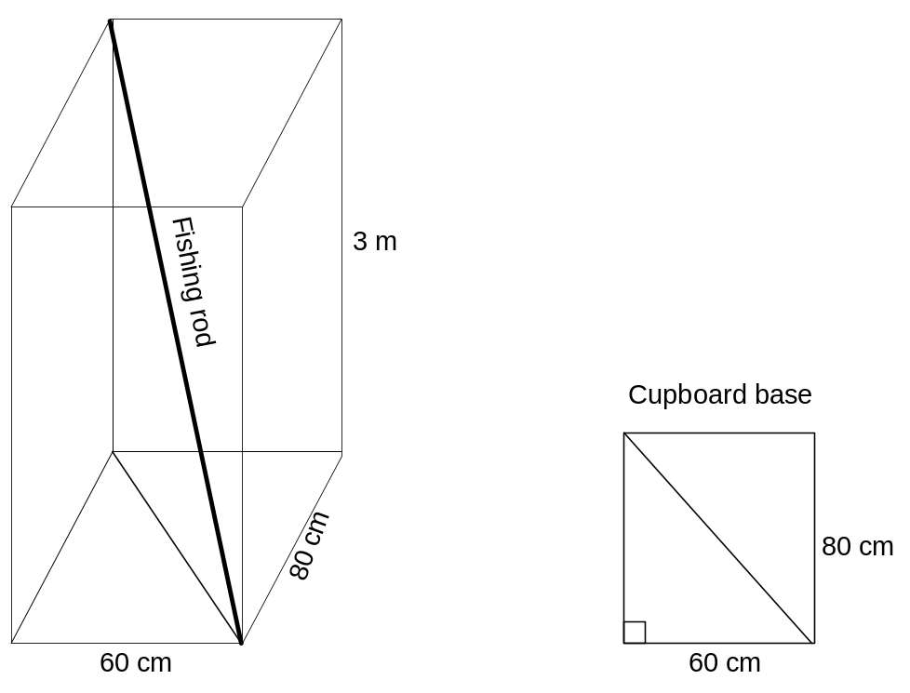
(a) Determine the length of the diagonal of the cupboard base. (2 marks)

(b) Determine the length of the fishing rod in metres correct to two decimal places.
(3 marks)

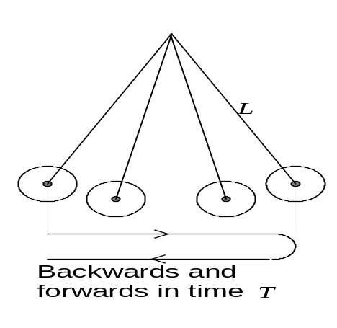8. (3 marks)

A pendulum swings backwards and forwards in time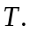
The length of the pendulum is.
The formula that links time and length is given by
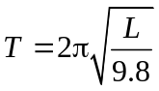 whereis in metres and in seconds.

Find the value of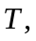correct to the nearest second, when is 30 cm.
Use the value of from your calculator. (3 marks)

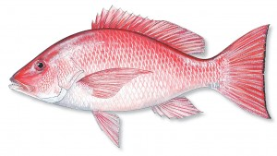
9. (5 marks)

To estimate the weight in kg, of a Red Snapper the following formula can be used where is the length of the Snapper in cm.

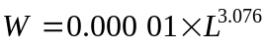

(a) Use your calculator to complete the following table. (3 marks)

Red Snapper
Length in cm | Weight in kg
30 | 0.350
40
50
60
70 | 4.737
80
90
100 | 14.191

(b) A Red Snapper is caught by a fisherman, but he left his ruler at home. He weighed the fish and found it was 0.56 kilograms.
The fisherman knew that any Red Snapper less than 40 cm must be released.
The fisherman had a copy of the table above.

What should the fisherman do? Explain. (2 marks)

10. (7 marks)

(a) A street light casts a shadow of a man onto the street with measurements in metres as in the diagram.
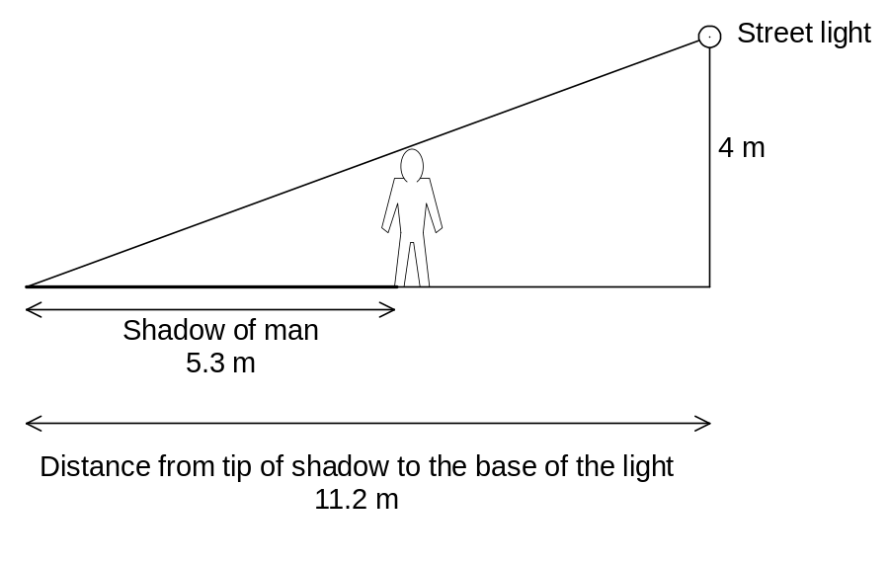
How tall is the man? (4 marks)

Continued next page.

Question 10 (continued).

(b) The map below shows two roads that go to the edge of a lake as in the diagram below.
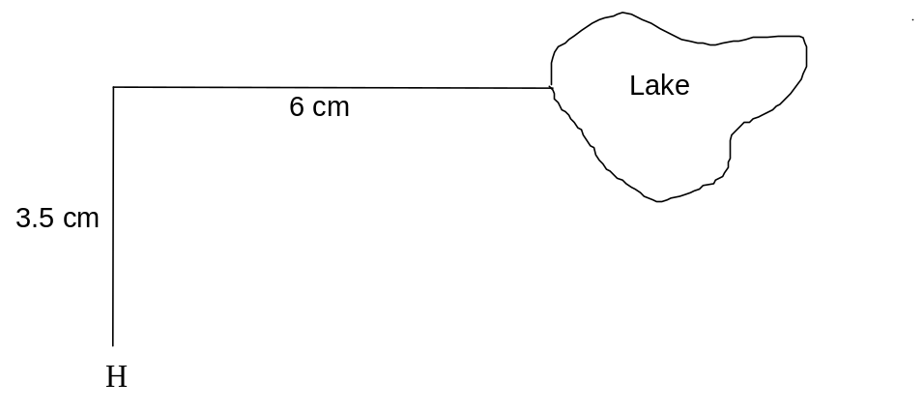

The road that is 3.5 cm on the map is actually 7 km long.
Bobbie lives at H.

(i) How many kilometres is it from H to the lake measured along the road?
(1 mark)

(ii) Estimate the greatest width of the lake. (2 marks)

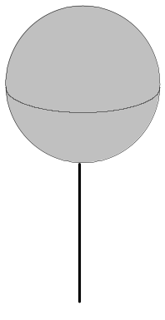11. (7 marks)
The three dimensional logo outside the Baked Bean factory is a sphere erected on a metal pole. The sphere had an external radius of 60 cm and an internal radius of 59 cm.
(a) Calculate
(i) the volume of the outer sphere. (1 mark)

(ii) the volume of the inner sphere. (1 mark)

(b) (i) Hence determine the volume of metal, to the nearest cm³, required to
construct the sphere. (2 marks)

(ii) Express the volume in (i) in m³. (1 mark)

(c) Calculate the surface area of the outside of the sphere. (2 marks)

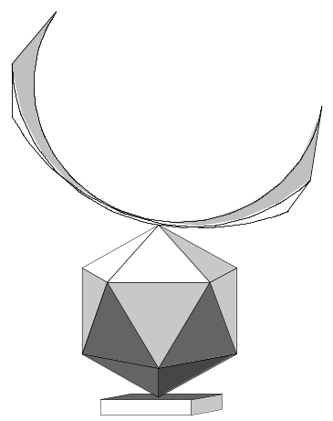12. (6 marks)

A model of a sculpture has surface area of 1200 cm³.

The sculpture itself is planned to be 15 times bigger in width,
In length and in height.

(a) What is the surface area of the sculpture? (2 marks)

The volume of the model is 2000 cm³.
(b) What is the volume of the sculpture? (2 marks)

The sculpture is to be made of bronze which costs $10 per kilogram.
There are about 0.0625 kg of bronze in every 2000 cm³ of the sculpture

(c) What is the cost of the bronze to construct the sculpture? (2 marks)

13. (12 marks)
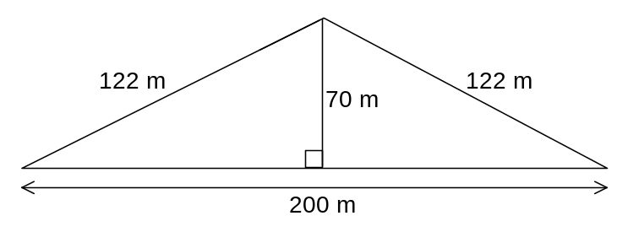 Calculate the perimeter and the area of each of the following. Show all working.
(a)

Perimeter = ______________ Area = ______________ (3 marks)
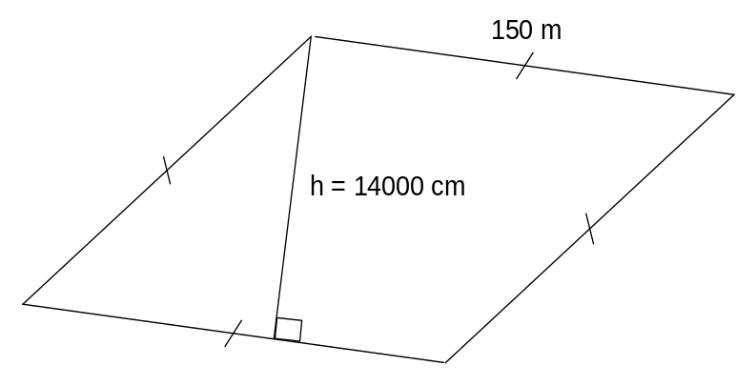
(b)

Perimeter = ______________ Area = ______________ (4 marks)

Continued next page.

Question 13 (continued).

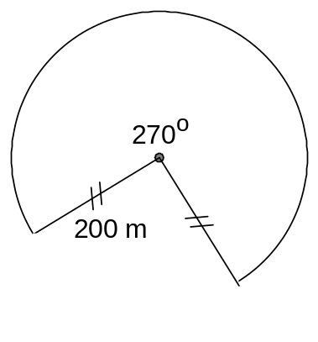 (c)

Perimeter = ______________ Area = ______________ (5 marks)

14. (7 marks)
A baker sold homemade steak pies, steak and kidney pies, pasties, sausage rolls and Cornish pasties. The baker was open Monday to Friday and the sales for one week during the lunch period are shown in the chart below.
 | Monday | Tuesday | Wednesday | Thursday | Friday
Steak pies | 10 | 11 | 10 | 9 | 9
Steak and kidney pies | 12 | 8 | 10 | 9 | 10
Pasties | 8 | 7 | 9 | 7 | 11
Sausage rolls | 11 | 12 | 10 | 8 | 9
Cornish pasties | 5 | 6 | 8 | 7 | 7

The baker sold the items for the following prices.
 | Cost
Steak pies | $4.80
Steak and kidney pies | $5.20
Pasties | $4.50
Sausage rolls | $3
Cornish pasties | $4.80

(a) Write down an expression in matrix form that when evaluated will given the
baker’s income from his steak pies, steak and kidney pies, pasties, sausage
rolls and Cornish pasties for each day of the week. (2 marks)

(b) Evaluate the baker’s income from these items for the week. (5 marks)

15. (13 marks)

- A narrow pool, designed for laps, is installed in a front garden. The pool is deeper at
one end than the other.
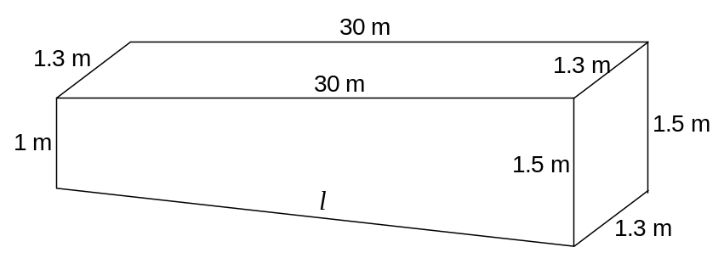
(i) Determine the length of the bottom of the pool.
Round to 4 decimal places. (3 marks)

(ii) Determine the area of the cross section of the pool as shown below.
(2 marks)
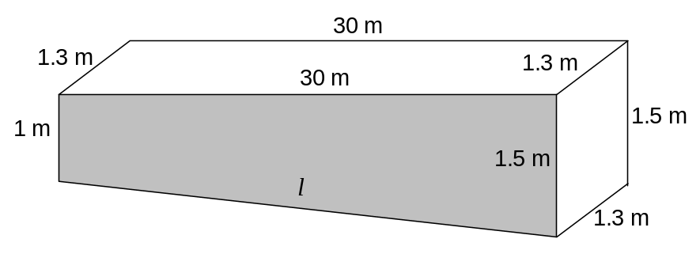

(iii) Determine the number of kilolitres of water required to fill the pool given
one kilolitre = 1 m³. (3 marks)

Continued next page.

Question 15 (continued).

(b) Consider the square based pyramid of perpendicular height 12 cm and base
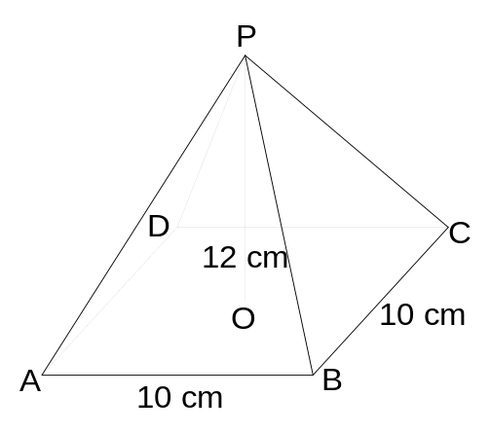 of length 10 cm.

(i) Let M be the midpoint of BC.
Determine the length of MP. (2 marks)
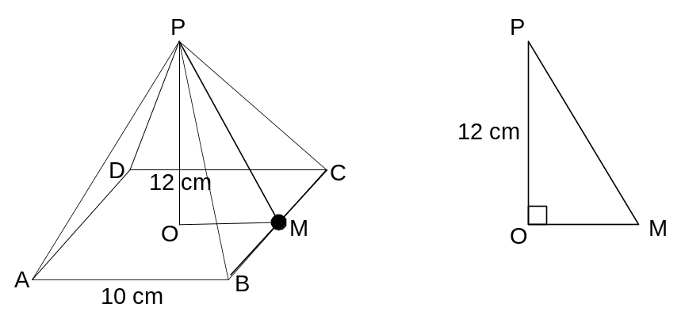

Continued next page.

Question 15 (continued).

(ii) Hence find the surface area of the square based pyramid. (3 marks)
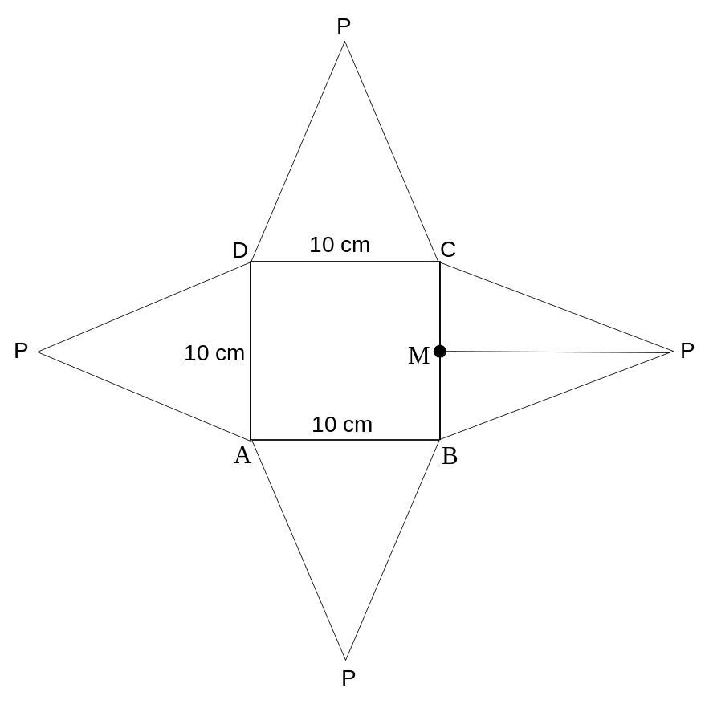

16. (17 marks)
(a) James needs a job so he can save for a year in order to support himself while studying the following year.

James’ alternatives are:

A He can earn $9 an hour at MacDonalds working 30 hours a week.

B He can earn $1500 a month with part-time work packing and shelving at
the local IGA.

Which is the best alternative financially? Show all working. (4 marks)

(b) Sally receives $560 a week and her wage is linked to inflation. If in 2014 inflation
was 2.3%, what is Sally’s increase per week in 2015? (2 marks)

Continued next page.

Question 16 (continued).

(c) Jane spends $240 a week on rent, $120 a month on electricity. $120 every two
months on gas, $45 a month for her mobile phone, $155 on petrol and car
expenses a month, $250 a month on food, $36 a week on social activities.
Jane is paid $36 000 a year and receives $2723 net per month.
There are 52 weeks in a year.

(i) Use the chart below to draw up a monthly budget. (4 marks)

Item | Weekly cost | Monthly cost
Rent | 240
Electricity |  | 120
Gas
Mobile phone
Car
Food
Social | 36
 | Total
 | Monthly nett pay | 2 723
(ii) What are Jane’s savings per month? (2 marks)

(iii) List the items that could be pruned from her budget if Jane decided
to save money for a deposit on a home. (2 marks)

(d) Due to a bad car accident, Jane’s brother Tom, is on a disability pension of $766 a fortnight.
Assuming Tom had identical expenses to those of Jane, can he afford to pay his
bills? (3 marks)

17. (4 marks)
Peter buys a Nikon camera online from B & H in New York. The cost of the camera is $235 US and Peter is charged $23.70 US for postage.

(a) Given $1 AU ≡ $0.75 US, determine the total cost in $ AU of the camera when
bought online. (3 marks)

The same Nikon camera is available in Australia at a cost of $380 plus10% GST.
(b) How much would Peter pay for the camera in Australia? (1 mark)

18. (8 marks)

Bill invests $2 500 at his local bank and earns 4.5% interest compounded monthly.
(a) Calculate the interest earned in the first month. (2 marks)

(b) Use the spreadsheet on your calculator to determine the values in the chart below and write down the values for Month 6. (3 marks)

Month | Opening Balance | Interest | Closing Balance
1 | $2 500.00
2
3
4
5
6

(c) Had Bill invested the money using simple interest for six months at 5% per annum, would he have received more or less than investing at 4.5% per annum compounded monthly for the six months? Explain. (3 marks)

19. (6 marks)
A computer game is priced online at $420. A discount of 25% is offered for the next 24
hours.

(a) What is the discounted price? (2 marks)

A local games shop is making $50 profit by selling the game at $410.
The shop also offers a discount of $25 for a cash sale.

(b) What is the local shop’s percentage profit on a cash sale? (4 marks)

END OF SECTION TWO

Extra page for working if necessary

Extra page for working if necessary

Extra page for working if necessary

